
Dashboard Design

Date | 27 October 2026
Team ID | Individual
Project Name | Global Olympic Sports Performance Analysis
Maximum Marks | 5 Marks

Creating an effective dashboard involves thoughtful design to ensure that the presented information is clear, relevant, and easily understandable for the intended audience. Here are some key principles and best practices for dashboard design
Activity 1: Interactive and visually appealing dashboards
Creating interactive and visually appealing dashboards involves a combination of thoughtful design, effective use of visual elements, and the incorporation of interactive features. Here are some tips to help you design dashboards that are both visually appealing and engaging for users so take care of below points
- Clear and Intuitive Layout
- Use Appropriate Visualizations
- Colour and Theming
- Interactive Filters and Slicers
- Drill-Down Capabilities
- Responsive Design
- Custom Visuals and Icons
- Use of Infographics

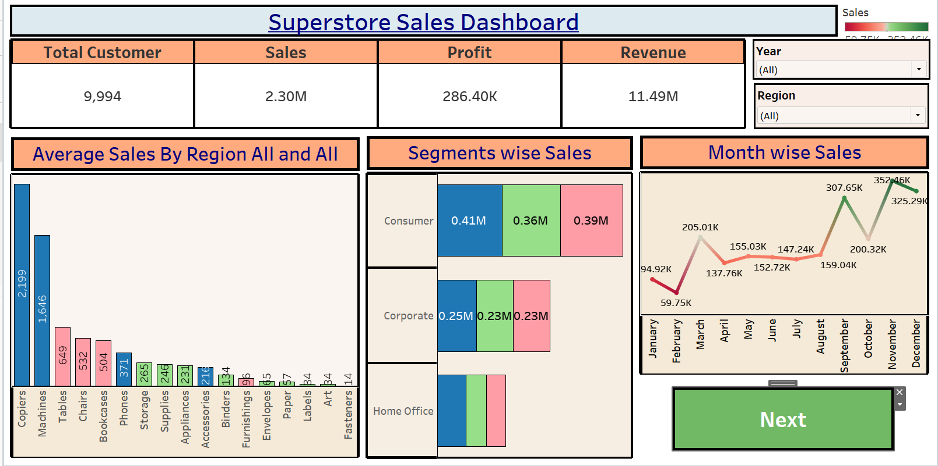
Note: Highlight the major outcomes in form of bullet points
Sample:
Here are five potential outcomes from the dashboard image provided:
- Customer Count and Sales Overview:The dashboard reports a total of 9,994 customers, with cumulative sales of 2.30M, a profit of 286.40K, and revenue of 11.49M. These figures highlight the overall scale and profitability of the store’s operations.
- Highest Sales: Copiers and Machines are the top-selling products, with sales values of 2.199M and 1.646M, respectively. This suggests strong demand or high price points for these products.
- Peak Month: December has the highest monthly sales at 352.46K, likely due to holiday shopping.
- Seasonal Sales Growth:The monthly sales chart shows growth in specific months, such as March, September, October, and December, likely influenced by seasonal factors and sales events.
- Sales Distribution Across Segments: The Consumer segment leads with 0.41M in sales, followed by Corporate at 0.25M, and Home Office at the lowest

Activity 2
Publish Dashboard on Tableau Public and Paste the Dashboard Public link below:
Example
https://public.tableau.com/views/SalesDashboard_17247660582000/Dashboard1?:language=en-US&publish=yes&:sid=&:redirect=auth&:display_count=n&:origin=viz_share_link
Planned 3 Dashboards
Dashboard arrangement is planned as follows; publish links and screenshots remain to be added after the workbook is completed.
Dashboard | Worksheets | Purpose
Dashboard 1 — Global Olympic Performance | Sheets 1, 2, 3, 6 | Country medal rankings, medal-type composition, Summer/Winter comparison, and sport-category average medal counts.
Dashboard 2 — Investment and Regional Efficiency | Sheets 7, 8 | Regional average recorded efficiency and medal outcomes by investment tier; no monetary ROI claim.
Dashboard 3 — Olympic Trends and Host Nations | Sheets 4, 5, 9 | Recorded medal trends, athlete participation, and host-nation performance.
Dashboard 1 — Global Olympic Performance (Sheets 1, 2, 3, 6)
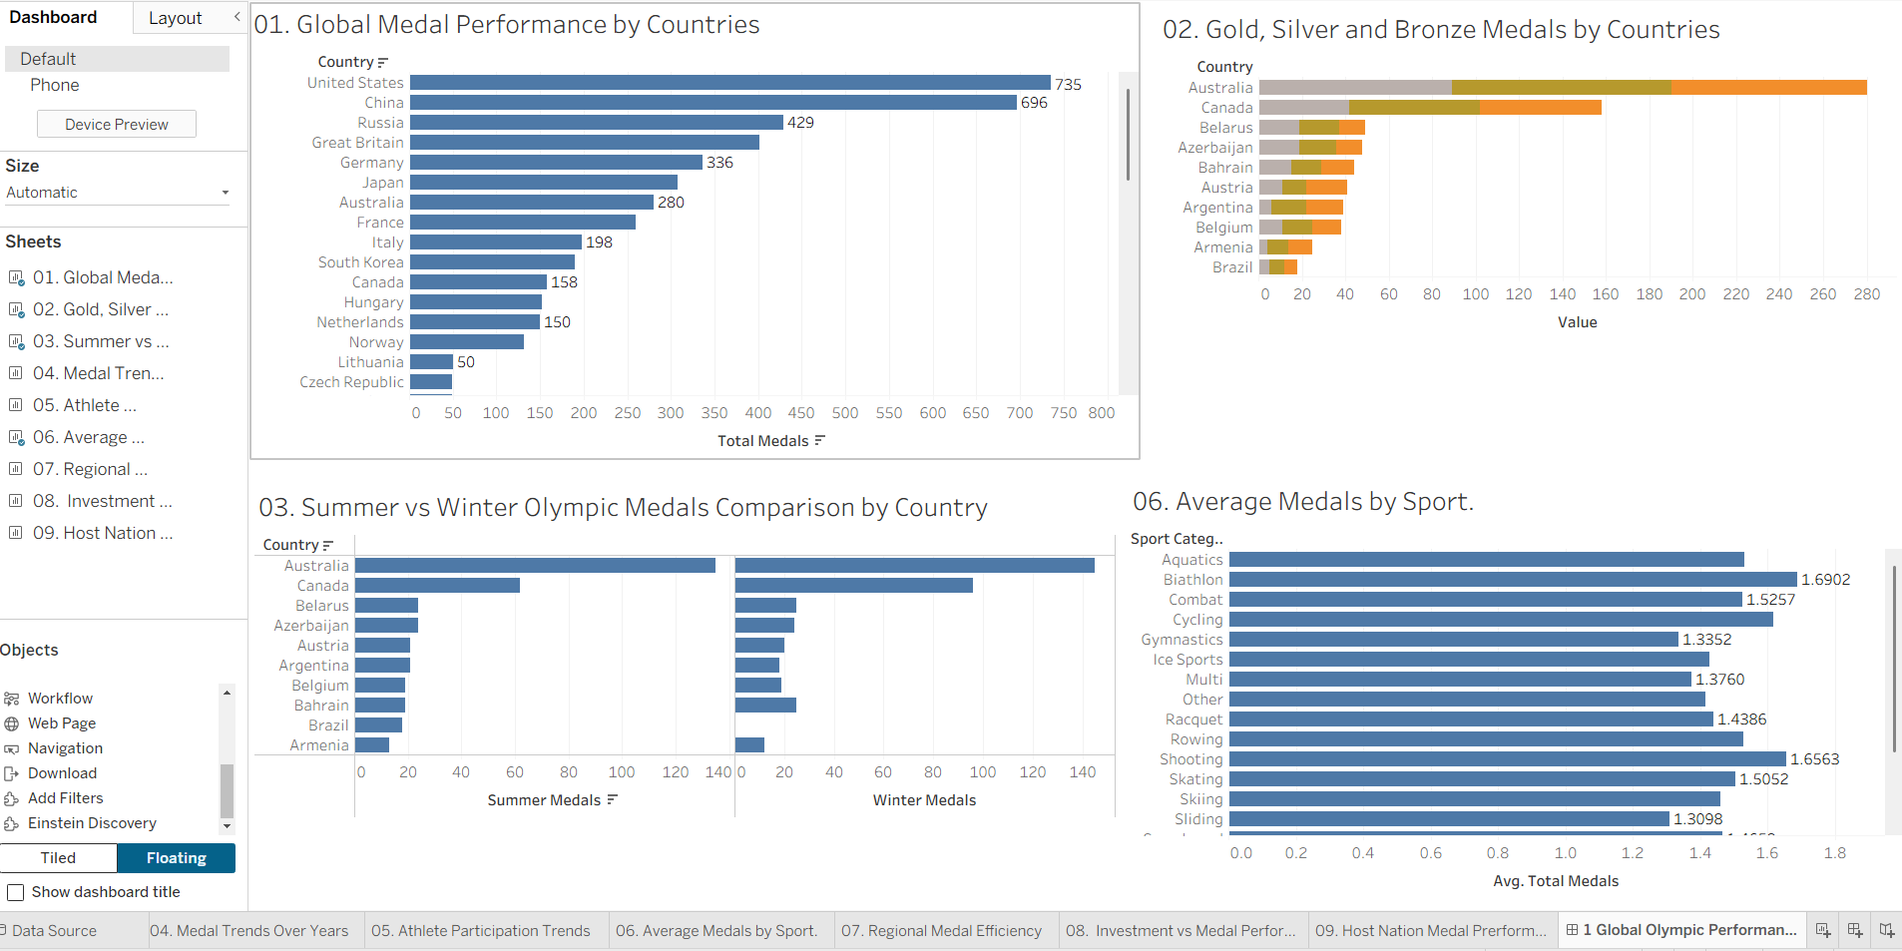
Dashboard 2 — Investment and Regional Efficiency (Sheets 7, 8)
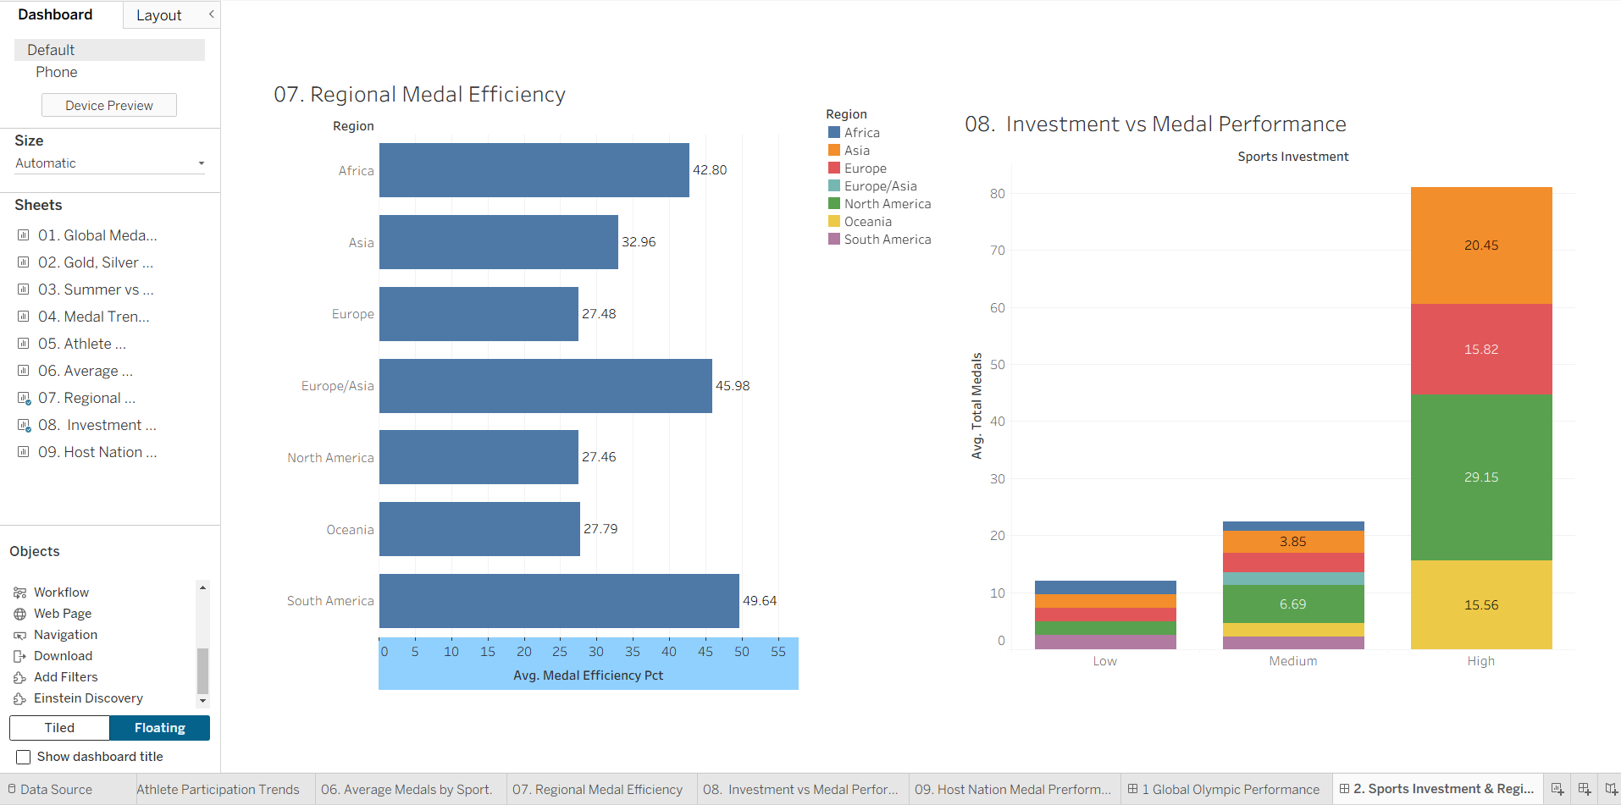
Dashboard 3 — Olympic Trends and Host Nations (Tableau screenshot)
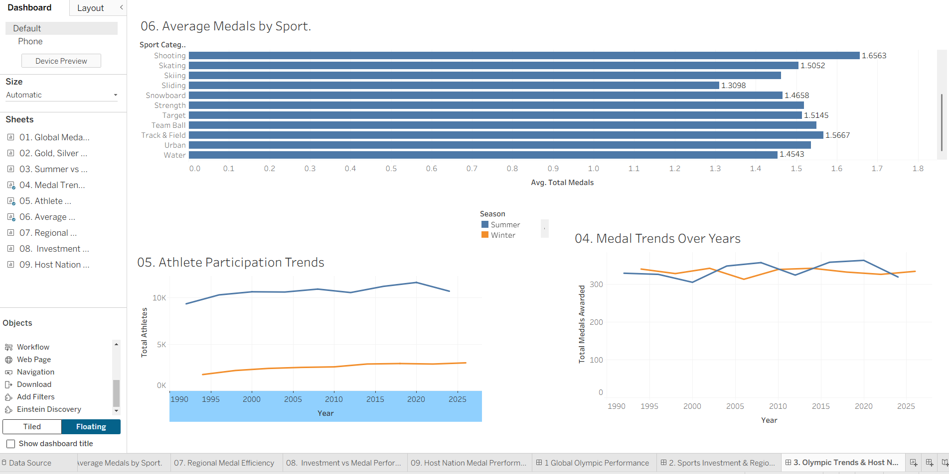
Major Outcomes to Report After Validation
• Country leaders: the United States leads with 735 total medals, followed by China (696), Russia (429), Great Britain (401), Germany (336), Japan (308), Australia (280), France (260) and Italy (198).
• Medal composition and seasons: the stacked gold/silver/bronze bars and the Summer vs Winter bars show how each country's total splits by medal type and by season (for example, Australia's 280 medals are roughly half Summer and half Winter).
• Sport categories: Biathlon (1.6902), Shooting (1.6563) and Cycling (1.6180) have the highest average medals per athlete record, while Sliding (1.3098) and Gymnastics (1.3352) are the lowest; the measure used is AVG(total_medals).
• Regional efficiency: South America has the highest average recorded medal-efficiency value (49.64), followed by Europe/Asia (45.98) and Africa (42.80); North America (27.46), Europe (27.48) and Oceania (27.79) are the lowest. This is the dataset's recorded metric, not monetary ROI.
• Investment tiers: the High investment tier shows the largest combined average medal totals across regions, Medium is much smaller and Low is the smallest; investment is categorical (High/Medium/Low), so no monetary ROI is claimed.
• Trends: recorded medals awarded move between about 305 (Summer 2000) and 363 (Summer 2020) per Games, and Summer athlete participation (about 9K–12K) is far higher than Winter (about 2K–3K), which has grown steadily since 1994.
Dashboard Public Link
Pending — paste the exact Tableau Public URL after publishing. Do not use a sample link.

